Minutes from SOCoP Meeting Dec, 17, 2013 (11:00 – noon EDT)

Attendees-Participants: Gary Berg-Cross (SOCoP Secretary) Peter Yim (Cim3), Nancy Wiegand (UW),Dalia Veranka (USGS),
The telecom was again provided by GMU 1-218-862-9364
Passcode: 953677#.

The following topics were discussed:

- Wrapping up the INTEROP grant
The grant officially ends Aug. 31 but it might end in effect June 30 depending on the money. Nancy is targeting end of May to have the bulk of report drafted.

The group discussed the major things do we still want to do. One of these was work on the Body of Knowledge (BoK). There is a Spatial Ontology Body of Knowledge (aka SOBoK) that Naijun has slowly been developing. Over the summer literature had been collected which would be complimentary to James' RefWorks bibliography. Naijun; intent has been to merge them into a single document, making it like a review article/material about spatial ontology. As a result this will not be the same as GIS BoK which discussed technologies, skills, methods, etc. Naijun has also been working on a demo with the visual tool, but the status of things in unclear.

The group also discussed doing something with the UCGIS BoK itself given its existing structure, perhaps based in part on Gary’s 5 page working outline of additions. Gary promised to look at this again as possibly formalize it and firm it up so that others may work on it.
OOR and Future Grants
The status and future of our OOR was discussed.
There are efforts underway considering if the OOR code should be based on Ontohub. Peter provided an update on what improvements OntoHub might include such as integration with an editor like Protégé.

Nancy asked Peter if we could use the SOCoP OOR for an EarthCube building block.
We would need tosubmit to EarthCube, by March 12.
The question is what functionality will EarthCube need? SOCoP OOR is mostly a content repository and would not be in jeopardy if things moved to OntoHub.
It is worth noting that the ESIP project is funded which includes a repository. The ESIP in January might provide an update on plans for their OOR.

Nancy should talk to Ken and Mike about the grant possibility. Peter noted that no grant has run long enough to be sustainable over time. Writing up a new grant for another infrastructure is probably not a winner, but something to maintain the content might be according to Peter.

Nancy asked if we should consider EarthCube RCN or Building Block grants. To date they have not been talking about spatial data and this might be a new area such as reading features.
Gary thought the RCN a possibility since we are a network, but perhaps not large enough and we might cooperate with some others./. Maybe we should check with ESIP.
How to spend the remaining participant support costs

There is enough money to consider another workshop. Do we want to do more major workshops or some smaller type gatherings?

Nancy asked for ideas and one is to do something as part of Jano's workshop at UCSB in March. Gary thought that a good idea and that Jano would welcome some support. We might have a topic to discuss, but the group would have to develop it.

We could do something in Madison again or in DC, perhaps another Vocamp. Gary thought a VoCamp would not be the best option and suggested a workshop that might show off our accomplishments and do more outreach. Gary thought it useful to show the OOR content and a its use in the workshop along with a demo of our tool and more on the use of GeoSPARQL and perhaps a tutorial on our methods. All of this needs effort.

Dalia’s opinion was that this would be helpful. We might consider a format like AAG which would include a 4 speaker panel on a related topic.
Gary would like to see if we could develop a tutorial on method.
Dalia noted that some are skeptical of geo-vocamp approach and this might be useful to discuss.
Planning for the Ontology Summit.
Peter noted that the 2014 Summit might be an opportunity to show cooperation. The span of activity is from Jan. with virtual meetings (Thursday meeting 12:30-2:30 EST.
) till April 28-29 when we meet in Ballston. Peter went through some of the tracks noting we had a good team of champions (Gary is one of the Content Co-champions).

• Track A: Common Reusable Semantic Content (42X1)
- Co-champions: MikeBennett, AndreaWesterinen, GaryBergCross (42X2)
• Track B: Making use of Ontologies: Tools, Services, and Techniques (42X3)
- Co-champions: ChristophLange, AlanRector ... GiancarloGuizzardi? (proposed: Krzysztof) (42X4)
• Track C: Overcoming Ontology Engineering Bottlenecks (42X5)
- Co-champions: KrzysztofJanowicz, PascalHitzler, MatthewWest (42X6)
• Track D: Tackling the Variety Problem in Big Data (42X7)
- Co-champions: KenBaclawski, PeterFox? (proposed: KrzysztofJanowicz), MalcolmChisholm? (proposed: MikeBennett), MarkGahegan? (proposed: KrzysztofJanowicz) (42X8)
• Track E: Hackathon (42X9)
- Co-champions: DanBrickley, AnatolyLevenchuk ... candidates: WernerKuhn? (proposed: KrzysztofJanowicz), ... KenBaclawski will also help in an advisory role given his experience from last year's hackathon (42XA)
• Track F: Data Collection, Community Library, Surveys, Ontology Repository, ... (42XB)
- Co-champions: AmandaVizedom?, OliverKutz? (proposed: PeterYim),

Nancy asked if could we have our workshop around that summit – say the Wed.-Th after that?
Gary may check with George Strawn at NITR who is the sponsor.

Update on GUI tool Development for SPARQL queries and Plans for UCGIS workshop
The Home Page URL for the Geoquery gui tool is http://geoquery.cs.jmu.edu
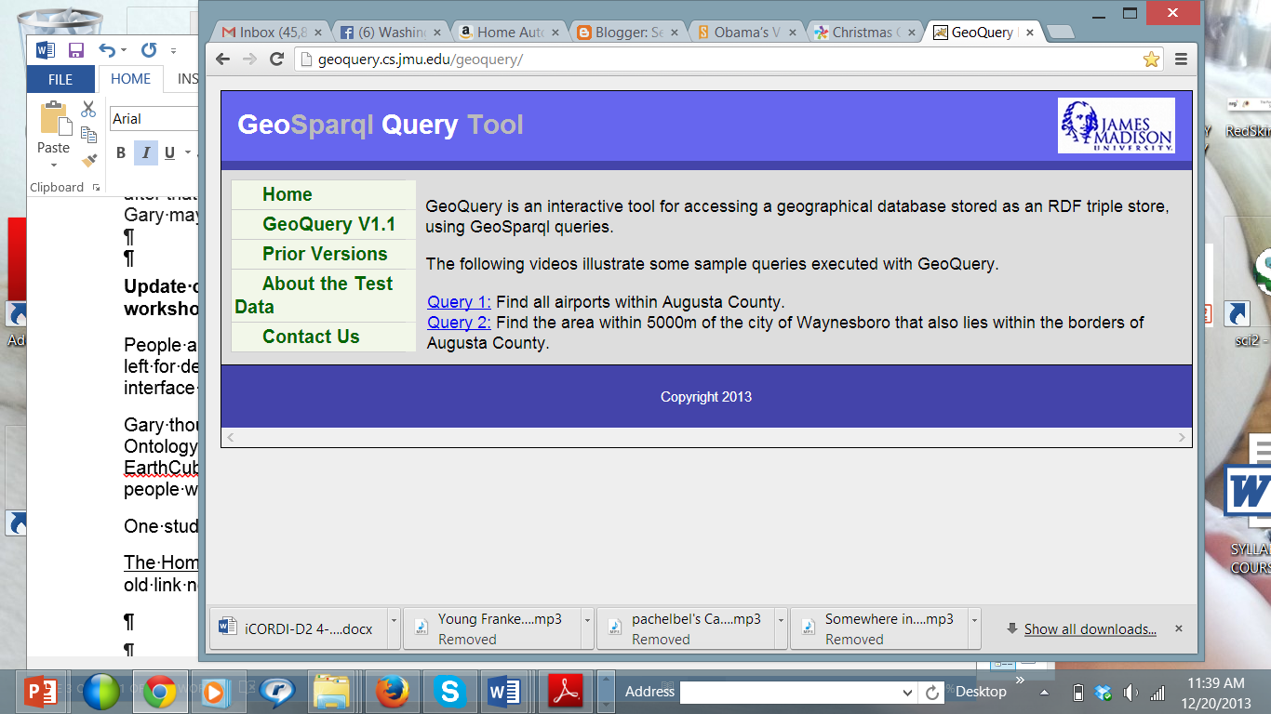
People are still discussed trying to use more data. Nancy noted that she is recruiting a student to work on data so far one student responded.

It is not clear if there is any money left for demo development. Currently there is no Help or tutorial to help learn the interface and these are needed.
Gary thought that we might try to organize some work on the tool as part of the Ontology Summit Hackathon. Nancy noted that James may do proposal with ESRI for EarthCube. This will be discussed at the ESIP conference in January and several people will try to be there.

Reviving SOCoP
Gary was prepared to discuss efforts to revive SOCoP and continue its operations past the grant. He has met with John Moeller, who plans on stepping down as co-chair. Gary and John discussed revising the existing charter and a draft of this has been drawn up. Gary would like to stay involved for a few more years and continue the annual workshops and demos as well as revise the monthly meetings to include more presentations on topics of interest to a wider community. John and Gary discussed a re-launch event similar to the original one to get things moving, perhaps in the Spring.

Next GeoVocamp at UCSB

Basic information about the workshop is now on the VoCamp under GeoVoCampDC2013. Nancy may attend. Gary is a co-organizer and plans on attending.
Note, some info on the Nov. SOCoP Vocamp is on the SOCoP site.

The meeting closed noting that the next session is tentatively planned for Monday or Tuesday. January 13-14. Gary may send out a Doodle to see what is a good day-time.

