SOCoP Meeting Minutes from Wednesday SOCoP Meeting Dec. 15 2010 from
11:00 - 12:00 EDT

Attendees/Participants: Gary Berg-Cross (Knowledge Strategies), John Moeller (Northrop Grumman), Peter Yim (CIM3), Dave Kolas (BBN Tech), Nancy Wiegand (U of Wisconsin), and Krzysztof Janowicz (Penn State), Mike Dean (BBN Tech), Laura Reece (TASC), Carl Diebert (Sandia Labs)

See http://piratepad.net/UGPm6oeIcc for informal notes generated during the meeting which partial formed the basis for the minutes.

Following introductions the group discussed:

1. Follow up on the Dec. 3 Workshop USGS facilities in Reston.

John thought the workshop, which had about 50 people a success with reasonable discussions. He thanked the USGS for its help and the good facilities in Reston. Carl said that he appreciated the work that Gary and others had done to make the workshop available to people who called in.

John asked the group for thoughts on the workshop and where we go next?

One obvious thing was to consider actions items from the Breakout on “Frameworks, Vocabularies, Demos”. These were:
- Merged concept for OWS-8, AIP-4, SOCoP demos.
- Develop & maintain the vocabulary development best practices.
- Prizes for creating the most same-as triples.
- Use existing tools and USGS linked data to create and publish derivative services.
- Publish page of existing tools available for use.
- Leverage INTEROP and create educational resources.

John and others noted one problem on the SOCoP Wiki - the slides discussing “Frameworks, Vocabularies, Demos” was not placed on the Wiki. Instead a copy of the guidelines was linked. Gary promised to add the proper slides to the Wiki and has done so.

Dave is still considering next step demo ideas on essential queries (small-number-of). He thought that a good goal would be to create a web-based interface that would show the combination of the data sources in a useful way. This would be something that could be left running all the time for people to play with. James and Todd and Dave all were talking about converging on this:
Todd was working on / talking about working on a general web framework for this sort of thing. At this point it's all about thinking of a nice clever use case although Dave did not think that this should slow us down from proceeding on a “Land Use” Use Case.

Note, other ideas from the workshop included:

- Query across multiple domain vocabularies
- OWS-8 “Look-aside” versus “Pass-through” semantic queries.’
- Operation of vocabulary formation “process”

These and the essential queries are not yet concrete, but some of this was part of the post-workshop discussion with Todd etc. added ideas on future demos etc. It would be nice to put together these ideas and post them to the group. Dave thought that we might make progress in a month's time.

Krzysztof also built on the workshop breakout discussion and pushed for Practice Guides, education, and the development of vocabularies and their implementation. One starting point would be a VOCamp on citizens as sensors based on the ontologies developed within the W3C SSN XG. Linked data will only work if we have some ontologies/vocabularies to align the data to (however, these ontologies do not need to be top-down but rather bottom-up as was emphasized in Krzysztof ‘s talk).

Nancy asked for clarification on this discussion of Best Practice, Practice Guides and Frameworks.

Laura, who was in discussion of Best Practices, responded that we need to capture lessons learned from the Demo and pass these along to the community. Who can formalize these?

Dave thought that several people would have valuable input including Krzysztof and Dalia both of whom had relevant efforts going on. We would need to build up ideas on Best Practice, Practice Guides and Frameworks as a group.

We might use the Forum to have the discussion and then move any products over to the Wiki.
Action - Gary can start a discussion on this topic in consultation with the larger group (Dave, Krzysztof, Todd, Josh, Dalia...)

There also should be some action on the Breakout sessions idea of publishing a page of existing tools available for use. The same people as on Best Practices would probably be involved, but this would have a separate thread and also then produce content to be placed on the Wiki. The question was who leads this and works with Gary to get it on Forum and Wiki.

While waiting for an answer to this question Nancy had a student look at Snoogle, but couldn't get it to work. We need a summary on the tool and what it is good for.
This would help us on things like Core MD requirement
John can work with Laura and Gary on this. An example of such a list that Gary suggests is at http://marinemetadata.org/tools

Gary provided a summary of the Land Use/Cover session (more cover than use).
Attendees included Dalia Veranka, Ola Ahlqvist (Ohio State U) , Gary Berg-Cross (SOCoP), James Wilson (JMU) , Kuan Song (UMD), Steven Marsters (BAH- MD work), Greg Joiner (BBN Tech) - Nancy was on the Phone. Gary had drafted notes from this meeting and they are on the Wiki, but Ola and Kuan will provide additions to this.

Ola discussed some of the challenges of the existing and more cognitive categories needed to handle geo features to support interoperability. He, like Krzysztof sees a need for a bottom up/domain approach for ontologies and has offered to provide some of these for the INTEROP work. Nancy was interested in Ola's data and ontology.
Kuan Song talked about UMD work on remote sensing and the problems of using automated classifiers for features. These classifiers all have hidden assumptions of closed system designed by Computer Science not Geographers. Bottom up ontologies developed with Geographers can be better.
Ola and James agreed that Land Use might provide a good Use Case for INTEROP to start with. Ola will think about what might go into this and also if some of his local ontologies might be formalized for such use.

Nancy noted that the AAG session will include New Zeeland land use example (see http://gisandscience.com/category/gis/) . There is also a Special Paper Session for 2010 AAG Annual Meeting, April 14‐18, 2010, Washington DC on Land Use Change and Watershed Assessment Sponsored by ICA Commission on Mapping from Satellite Imagery. For all these reasons Nancy thought this an Interesting topic for work

John noted that the US has a standard for Land Cover taxonomy – (TC 211 classification). Others may be different standards, but there are issues in sharing data across different taxonomies. Lots of systems that don't match up.

Carl raised issue and opportunity about high resolution. The issue it that such data is not matching up. We now can get LandSat data for free and it lets us look at find details such as trees. The Google Foundation has provide infrastructure to get this new data out to public. So there is a new opportunity for use of this data. But this raised the issue of resolving trees and smaller structures like shape of a roof as evidence of Building. “There is a workhorse statistical methodology called stratified sampling.
With the efficiency of stratified methods, most all surveys would be impossible.”

Carl needs to do diligence on possible opportunities, but there is an issue using existing classifications. They are useful for larger scale things. Now bottom up provides a different meaning to some of that. We can see to classes of things at the building level, not just at high density urban area. So if we do a detailed analysis at hi res what does it mean at the more abstract level and their extrapolation? We need to link from what we mean (tree) to a larger inductive inference that land cover is a "forest". This may allow better work to be done with a better vocabulary.

After the meeting Carl dug deeper to see what work has been done and provided the following context to what he was thinking of:

One might use “something like 30-meter Ground Sample Distance (gsd) Landsat images to stratify samples taken over a wide area, and where the sampled areas are measured at, say one-foot gsd (relatively high resolution). It didn't take much poking to find land use analysis that used stratified sampling in this context. The MDA Federal people (it would appear at the link below) went so far as to give it a name, "frame sampling":
http://www.mdafederal.com/environment-gis/national-security-policy-support/land-use/
If we were doing something commercial, I suppose we would have to check to see if they had also soiled the IP landscape with patents and such. If we SOCoP folks are just doing a use case, then maybe we just run with it.”

Since the idea of enhanced vocabularies had been raised Gary suggested posting a query about improved vocabularies to the SOCoP forum. John added suggested the FGDC-STD-005Natural Vegetation standard which is relevant (see http://www.fgdc.gov/standards/projects/FGDC-standards-projects/vegetation/index_html).

Krzysztof commented that the topic of feature type might be discussed in a VoCamp.

2. Update on the NSF Cyberinfrastructure Grant

Nancy had some topics to discuss starting with:

- the SOCoP Forum thread.
The recent discussion on the Ontology Summit resulted in up to 30 messages a day. This could overwhelm people on the grant and turn them off. She asked if there is a different way to have discussions. Gary noted that the SOCoP INTEROP would have its own Forum, which would probably have its own list and thus might have more limited discussions avoiding things on Ontolog and even on SOCoP.

Peter built on this idea of a separate forum and noted that the recent messages were not form the general Ontolog community but was from and for the Ontology Summit community. Peter explained that the Forums are used as a form of a Knowledge repository.
If there is an overload on a topic the solution might be that one person could send one message to "go here" to see the email thread. This is allowed by having 3-4 different ways to register for message distribution:
Daily Digest, as email, or as Archive.
The archive allows people to browse the messages when they want. But they can’t post if they just use Archive. Peter described a 4th option which is a folder where messages go and you can go there at end of day (like a Digest, but you can respond.)
This option allows you to filter the messages since they are not going to your inbox. This sounded like a solution to Nancy’s concern.

- Nancy also had questions about the Educational Component.
NSF funded a BoK2 project (PI Sean C. Ahearn, Hunter College ) see http://www.fgdc.gov/ngac/meetings/june-2010/geographic-information-science-body-of-knowledge.pdf . There is also the older BoK1 older project– UC GI S&T Body of Knowledge http://www.ucgis.org/priorities/education/modelcurriculaproject.asp with 10 knowledge areas and 73 units published by AAG. One is on Geospatial Data. See Figure below for some of this work, including a Unit’s form of knowledge for a Topic. The old home page also includes a list of their BoK advisors.)

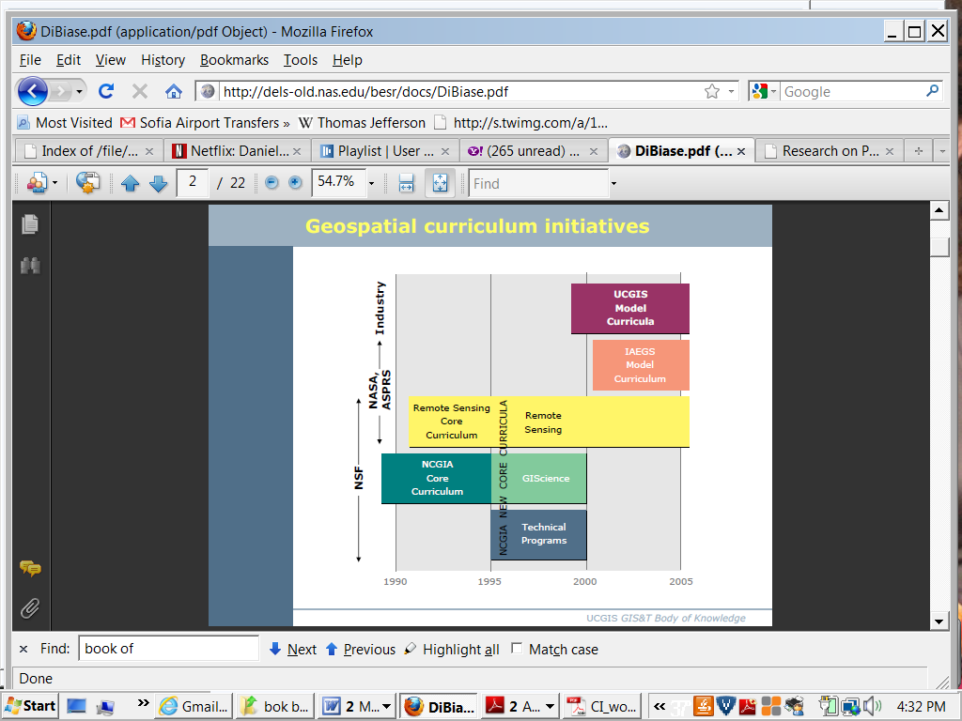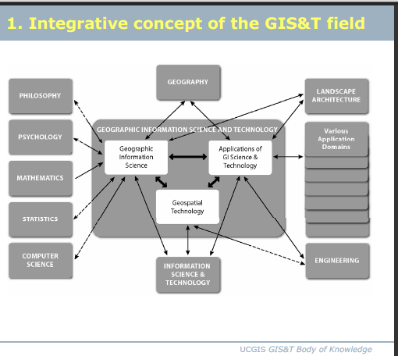

Example of BoK Topic AM4-3 Neighborhoods
•Discuss the role of Voronoipolygons as the dual graph of the Delaunay triangulation
•Explain how Voronoipolygons can be used to define neighborhoods around a set of points
•Outline methods that can be used to establish non-overlapping neighborhoods of similarity in raster datasets
•Create proximity polygons (Thiessen/Voronoipolygons) in point datasets
•Write algorithms to calculate neighborhood statistics (minimum,maximum, focal flow) using a moving window in raster datasetsTopic AM4-4 Map algebra
•Describe how map algebra performs mathematical functions on raster grids
•Describe a real modeling situation in which map algebra would beused (e.g., site selection, climate classification, least-cost path)•Explain the categories of map algebra operations (i.e., local, focal, zonal, and global functions)
•Explain why georegistrationis a precondition to map algebra
•Perform a map algebra calculation using command line, form-based, and flow charting user interfaces

Unit AM4 Basic analytical operations (core unit)
This small set of analytical operations is so commonly applied to a broad range of problems that their inclusion in software products is often used to determine if that product is a “true”GIS. Concepts on which these operations are based are addressed in Unit CF3 Domains of geographic information and Unit CF5 Relationships.
*************************************************************************

We should see what model the current NSF funded group is using for the BoK and keep in mind for our Wiki pages. Nancy will contact Sean to get guidance on this. Note BoK 2 aims at creating a “transformational, dynamic environment for pedagogy”, and will include “ontological analysis”.
Among the research questions of common interest to us and them are issues around knowledge development, validation and sharing including:

• How can a virtual community foster knowledge development?
• Can a knowledge base be both collaborative (open to contribution from a large community) and authoritative (so that its content can be trusted and used reliably)?
• What technological or institutional mechanisms can resolve this (above) seeming paradox?
• Can an environment for pedagogy be created for use at different levels of expertise?
• Can we use the same knowledge base environment for teaching, research, and professional practice?
• Is it feasible and advantageous to organize the BoK2 into a serious of flexible and interactive “knowledge rooms and virtual workspaces in a Virtual Persistent Environment?

- Nancy announced that she is moving to the U of Wisconsin Space Science and Engineering Group which has lots of remote sense weather data.
The current schedule is that Nancy will transfer the grant into the new group on January 1. Indeed the group has work on Earth science data exploring Meta Data and ontologies. This should be good for our work.

John Roberts is the grants person who can be contacts about being paid and will send his email to the relevant parties later.

Mike suggested an alternative that maybe we can send him our information so he can contact us. As a compromise Nancy compiled a list for John Roberts.

- Initial Planning
There was further discussion of coordination activities and Nancy was interested in suggestions on which groups to contact and who to target for our work. We do have monies in the grant to have our own sessions although the initial idea was to have our meetings collocated with previously planned conferences and workshops. Choice of such conferences will determine the timing for our first workshop. We did submit an Abstract to the ASPRS (The American Society for Photogrammetry and Remote Sensing ) 2011 Annual Conference:, May 1 to May 5, 2011, in Milwaukee, Wisconsin The conference theme "Ride On The Geospatial Revolution". We also have a session at AAG and there is a Wisconsin state GIS group talk every year (February). Maybe we will have a workshop at one of them. Nancy also mentioned a Spring meeting, this year in Boise Idaho, that she usually attends and includes relevant sessions.

The group had a brief discussion on plans to develop Use Cases. Who has a Use Case we can use?
One question was whether we should stay with Land Use or Cover or go with Marine data? Dave said that he was happy to go with a general one like Land Use as opposed to trying to find something that fits things like the existing use cases we had with past demos.

Gary suggested that along with a Use Case we need some supporting example Vocabulary and Ontology to show at even our initial meeting so this is not just a brainstorming session. We might contact some scientists before a first session and have some brainstorming (vocabulary and use case) with them. Mike, thought that maybe we need a brainstorming session with Space folks. We need to develop some methods for doing such things at our session. Preliminary work on the Wiki might include issues on naming. Some discussion of these issue and methods will be posted on our Wiki.

Gary also discussed the idea of using individual use cases, like perhaps Land Use, appropriate for one group of scientists and over time building up a larger, integrated use case that illustrated greater data fusion across a range of geo-date. This is somewhat aligned with the idea of bottom up vs. top down ontologies as discussed at our December workshop.

Nancy, wondered how would we do this, if we had a Workshop at Wisconsin as a friendly place to brainstorm? Would people come here, or we go to another location? Not sure of which strategy would work since we have money to travel to a workshop.

In discussing related work Nancy noted that GMU’s Department of Geography and GeoInformation Science group (http://ggs.gmu.edu/) (contact point is Peggy Agouris) may have similar interest so we might do a joint thing.

Dalia asked if these workshops will be Open to other participants or is it just for people on the SOCoP INTEROP grant. Nancy replied that no workshops are open but we have limited funds. So if people can pay their way they are welcome to participate. Gary added that we would want to have a broad community participate. Dalia was interested in part because USGS is developing a Use Case and has an interest in Land Use. Indeed several topics are interesting to USGS such as floods. These and USGS data may play a cooperative role in the SOCoP-INTEROP work.

- OOR
Gary raised several OOR issue that would be good to resolve as we move forward. One is to have a geospatial area in the exisiting OOR sandbox. One reason this is important is that an ontology like SWEET consists of several dozen modules which gets scattered by name across the list unless they can be grouped by the geospatial topic. Mike had looked into both issues as requested and both were currently more difficult to do than he would like. These can hopefully be resolved so Gary can proceed to add some other onotolgies.

Another question was we would continue to use this instance of the OOR?? Mike thought that it was transitory and that we are looking at hosting our own to expedite the use of our particular materials etc.

Gary asked about the reality of doing ontology mapping in the OOR (is http://oor-01.cim3.net/). Mike said that some mapping had been done manually in the OOR, but there are tools (Isalbelle Cruz Agreement maker) to help with this. Mike said that the BioPortal has done some bulk mapping. The paragraph below is from Noy et als discussion on Ontology Mappings in “BioPortal: A Web Repository for Biomedical Ontologiesn and Data Resources” (protege.stanford.edu/conference/2009/abstracts/S3P1Noy.pdf) see also https://bmir.stanford.edu/file_asset/index.php/1375/BMIR-2008-1343.pdf “Collecting Community-Based Mappings in an Ontology Repository” by Natalya F. Noy, Nicholas Griffith, Mark A. Musen

“Ontologies in BioPortal, as in almost any ontology repository, overlap in coverage. Thus, mappings among ontologies in a repository constitute a key component that enables the use of the ontologies for data and information integration. Thus, mappings between ontology concepts are first-class objects in the BioPortal repository. Users can browse the mappings, create new mappings, upload mappings created with other tools, download mappings that BioPortal has, or comment on the mappings and discuss them [see Collecting Community-Based Mappings in an Ontology Repository”]. Each mapping has its own set of metadata that describes who created the mapping and when, which algorithm was used to produce the mapping, application context in which
the mapping might be valid, the specific mapping relationship, and other properties. At the time of this writing, the BioPortal mapping repository contains more than 30,000 mappings created by biomedical researchers in different contexts.”

Gary thought that such mappings would be needed for the 2nd workshop if not earlier since we might have multiple vocabularies and ontologies by then and would be showing a 2nd group is geo-scientists how their concepts relate to the earlier groups’.

3. Plans for 2011 were not discussed nor was there time for the topic of web conferencing for 2011 meetings, which would facilitate presentations and demos as well as allow broader chat comments
and serve as a preparation for such activities during INTEROP sessions.

Jan 19 2011 was set as the target time for the next meeting.

